K.V.G. COLLEGE OF ENGINEERING
Kurunjibhag, Sullia, D.K.-574 327, Karnataka, INDIA
E-mail: office@kvgengg.com website: www.kvgengg.com

Department of Physics

FACULTY PROFILE

Name of the Faculty |  | LAVA N.D |  |  |  |  | 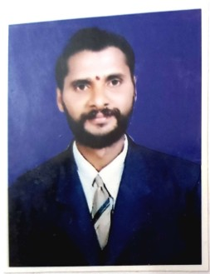
Designation |  | Sr. Attender
Contact Number
 |  | Mobile: +91 – 9449217881
E-mail ID |  | -----------
- Educational Qualification

Qualification | Year of Passing |  |  | College & Board
S.S.L.C. | 1986 |  |  | Government High School ,Yenekal,Subrahmanya  Karnataka Secondary Education Examination Board
- Work Experience
Attender |  |  |  |  | Sr. Attender
21+ years’ Experience |  |  |  |  | 12+years’ Experience
- Date of Joining to the College
15th December 1989

- In-House Experience
Designation |  |  | Duration |  |  |  |  | Department
 |  |  | From |  |  | To
Attender |  |  | 1989 |  |  | 2000 |  | CIVIL
Attender |  |  | 2000 |  |  | 2010 |  | PHYSICS
Sr. Attender |  |  | 2010 |  |  | Till the date |  | PHYSICS
- Responsibilities Carried out at department and College Level
- Worked as member in stage committee of Founder’s Platinum Jubilee Celebration.
- Worked as member in food committee of department and college level functions / events.
- Worked as member in Ayudha Pooja Committee.
- Helper for IA Tests
- Helper for First Year Induction Programme
- Helper in Sports day
- Helper in Workshop organiged in KVGCE
- Worked in Survey Camp of Civil Department
Mr. LAVA N.D, PHYSICS DEPT., KVGCE, SULLIA, D.K - 574 327.
Reach me @ 9449217881

